Contents
Context 1
SQL errors 1
Enter substitution variable 1
ORA-00904: Invalid Identifier 2
ORA-00918: Column ambiguously defined 3
ORA-00932: inconsistent datatypes: expected DATE got NUMBER 4
Visual Studio errors 5
BC30203 Identifier Expected 5

Additional Guidance
Knowledge Article: not yet written
HOW TO - Manage Reports - Access Permissions within HR Reporting.docx
HOW TO - Manage Reports - Change Processes in OSM.docx
HOW TO - Manage Reports - HR Reporting Environments.docx
HOW TO - Manage Reports - Parameters.docx
HOW TO - Manage Reports - Release and Deployment.docx
HOW TO - Manage Reports - Shared Data Sources.docx
HOW TO - Manage Reports - Shared Datasets.docx
HOW TO - Manage Reports - Visual Studio Basics.docx

Context
This document contains a list of error messages commonly encountered when writing reports in SQL Developer and rendering them in Visual Studio. An explanation of each error is provided, and where a resolution exists, this has been provided as well.

Any new error messages encountered by report writers should ideally be captured in this document so that resolutions, when identified, may be added here.

SQL errors

Enter substitution variable

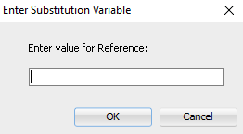

This window pops up in SQL Developer if there is an ampersand (&) anywhere in the report code. Replace the ampersand with the word “and”.

Alternatively state the command SET DEFINE OFF at the top of your code before the SELECT statement, and highlight it before pressing the “Run” button:

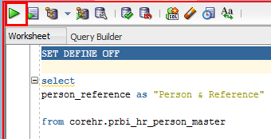

The SET DEFINE OFF command tells SQL Developer to ignore variables within the SELECT statement.

ORA-00904: Invalid Identifier

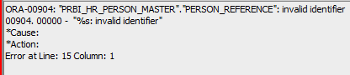

This error occurs when your code references an ITEM or VIEW which does not exist.
- Check that the item and/or view in the error line referenced by the error message isn’t misspelled (e.g. PESRON_REFERENCE instead of PERSON_REFERENCE, PRBI_H_PERSON_MASTER instead of PRBI_HR_PERSON_MASTER).
- If your code has multiple layers (Base Query, Subquery / Subqueries, Main Display Layer), make sure that the view references are not included beyond the Base Query unless they are explicitly stated in the FROM statement:

Incorrect | Correct
===MAIN (DISPLAY) LAYER===  SELECT  View.Item  FROM  ===BASE QUERY===  (SELECT  View.Item  FROM  Database.View) | ===MAIN (DISPLAY) LAYER===  SELECT  Item  FROM  ===BASE QUERY===  (SELECT  View.Item  FROM  Database.View)

In the example screenshot above, the report code has a Base Query and a Main Display Layer. The Main Display Layer is selecting the item PERSON_REFERENCE from the Base Query, rather than directly from the COREHR database, so it does not need to refer to the view PRBI_HR_PERSON_MASTER. The reference to the view needs to be removed from the error line in order to resolve this error.

ORA-00918: Column ambiguously defined

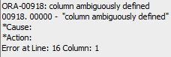

This error occurs when your code references the same item more than once in a single SELECT statement, e.g.:

SELECT
View.Item1,
View.Item2,
View.Item3,
View.Item1 – duplicate reference

FROM
Database.View

The code cannot be executed because it’s attempting to pick up the same item multiple times. You can either remove the duplicate reference, or use aliases to give the item different labels, e.g.:

SELECT
View.Item1 as “Personnel Number”,
View.Item2 as “Forename”,
View.Item3 as “Surname”,
View.Item1 as “Employee Lookup Value”

FROM
Database.View

The code can now be executed because it has given the duplicate items two separate aliases, so it can differentiate between them.

ORA-00932: inconsistent datatypes: expected DATE got NUMBER

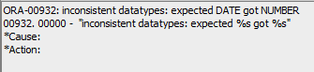

This error occurs if your SQL query is attempting to compare two dates within a calculation or a WHERE condition, and one of the dates is not in “Date” format.

- Check for any TRUNC() functions wrapped around dates. The TRUNC() function attempts to read anything within the brackets as if it is in date format. If you feed a non-date variable into a TRUNC() function, such as a text string or an integer, TRUNC() can’t understand what you’re asking it to do.

ORA-01790: expression must have same datatype as corresponding expression

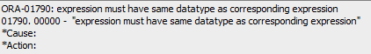

This error occurs if you are attempting to UNION two (or more) queries and the column ordering is not identical across the queries. A UNION statement tells SQL to append the results of Query 2 to the results of Query 1, like so:

Query 1

Q1 Name | Q1 Date of birth | Q1 NI Number | Q1 Email

Query 2

Q2 Name | Q2 Date of birth | Q2 NI Number | Q2 Email

UNION table:

Q1 Name | Q1 Date of birth | Q1 NI Number | Q1 Email
Q2 Name | Q2 Date of birth | Q2 NI Number | Q2 Email

The error occurs if the columns are out of sync when SQL tries to join the two queries:

Q1 Name | Q1 Date of birth | Q1 NI Number | Q1 Email
Q2 Name | Q2 NI Number | Q2 Date of birth | Q2 Email

Check the column order in the queries you are attempting to UNION to ensure they are identical. Move columns around as necessary in your SELECT statements until your queries have the same columns in the same order, and try again. This should resolve the error.

Visual Studio errors

BC30203 Identifier Expected

You may see this error when attempting to preview a report within Visual Studio. Check the Expression value for the Parameters textbox within your report:

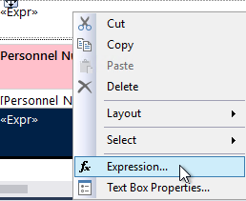

The VBA expression in this textbox is what generates the parameter statement at the top of a finished report, confirming what parameters were selected:

Make sure that every parameter field is identified as a .VALUE or a .LABEL item within the VBA expression code. If the .VALUE or .LABEL identification is missing from the parameter string, you need to add it back in, or the VBA expression will be invalid:

